Introducing CorelDRAW Technical Suite 2019!

Hello CorelDRAW community!

We’re excited to announce that CorelDRAW Technical Suite 2019 is now available! The newest member of the CorelDRAW product family has been designed specifically to meet the needs of technical communicators with new features and updates to maximize tech illustration and drafting workflows.

For our community members who may not already be familiar, Technical Suite builds on the core power of CorelDRAW Graphics Suite 2019 for Windows with the addition of two exceptional technical illustration products -- Corel DESIGNER for precision illustration and technical design and XVL Studio Corel Edition with 3D visualization and authoring capabilities.

Customers in technical industries like engineering, manufacturing, and architecture depend on the suite’s unique feature set and impressive graphics pedigree to produce precise illustrations, including assembly instructions and complex schematics -- whether they’re creating original designs or working from 3D CAD renderings.

Here are some of the highlights of the new release that empower technical users to work faster with impressive precision and control.

Enhanced isometric drawing helps you produce complex illustrations efficiently with pinpoint accuracy. Draw on projected planes and redefine drawing planes, plus explore updates to the Projected Axes docker that make projected drawing workflows more intuitive.

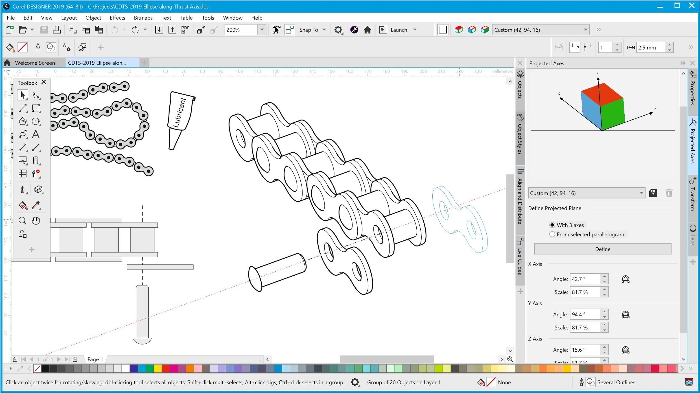
New Isometric Drawing Updates

The new Objects docker (which you may already be familiar with from CorelDRAW 2019) is now included in Corel DESIGNER too, giving you greater control over your technical documents by making it easy to manage objects, layers, and pages seamlessly.

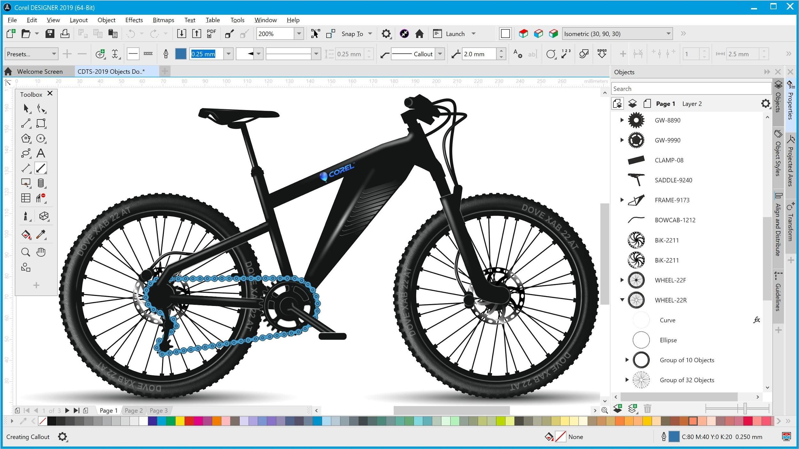
New Objects Docker now in Corel DESIGNER 2019 and CorelDRAW 2019

The Styles workflow has been enhanced -- making it possible to ensure a consistent visual style across technical publications in less time. Take advantage of the ability to apply existing Style Sets as well as new preloaded Style Sets that follow S1000D technical illustration standards.

And rounding out the suite, we include the new CorelDRAW.app that enables you to access your files from virtually any device and create new vector designs and illustrations on the go. Plus the enhanced XVL Studio Corel Edition also delivers a number of updates that are ideal for anyone who leverages 3D designs from existing sources as part of their workflow.

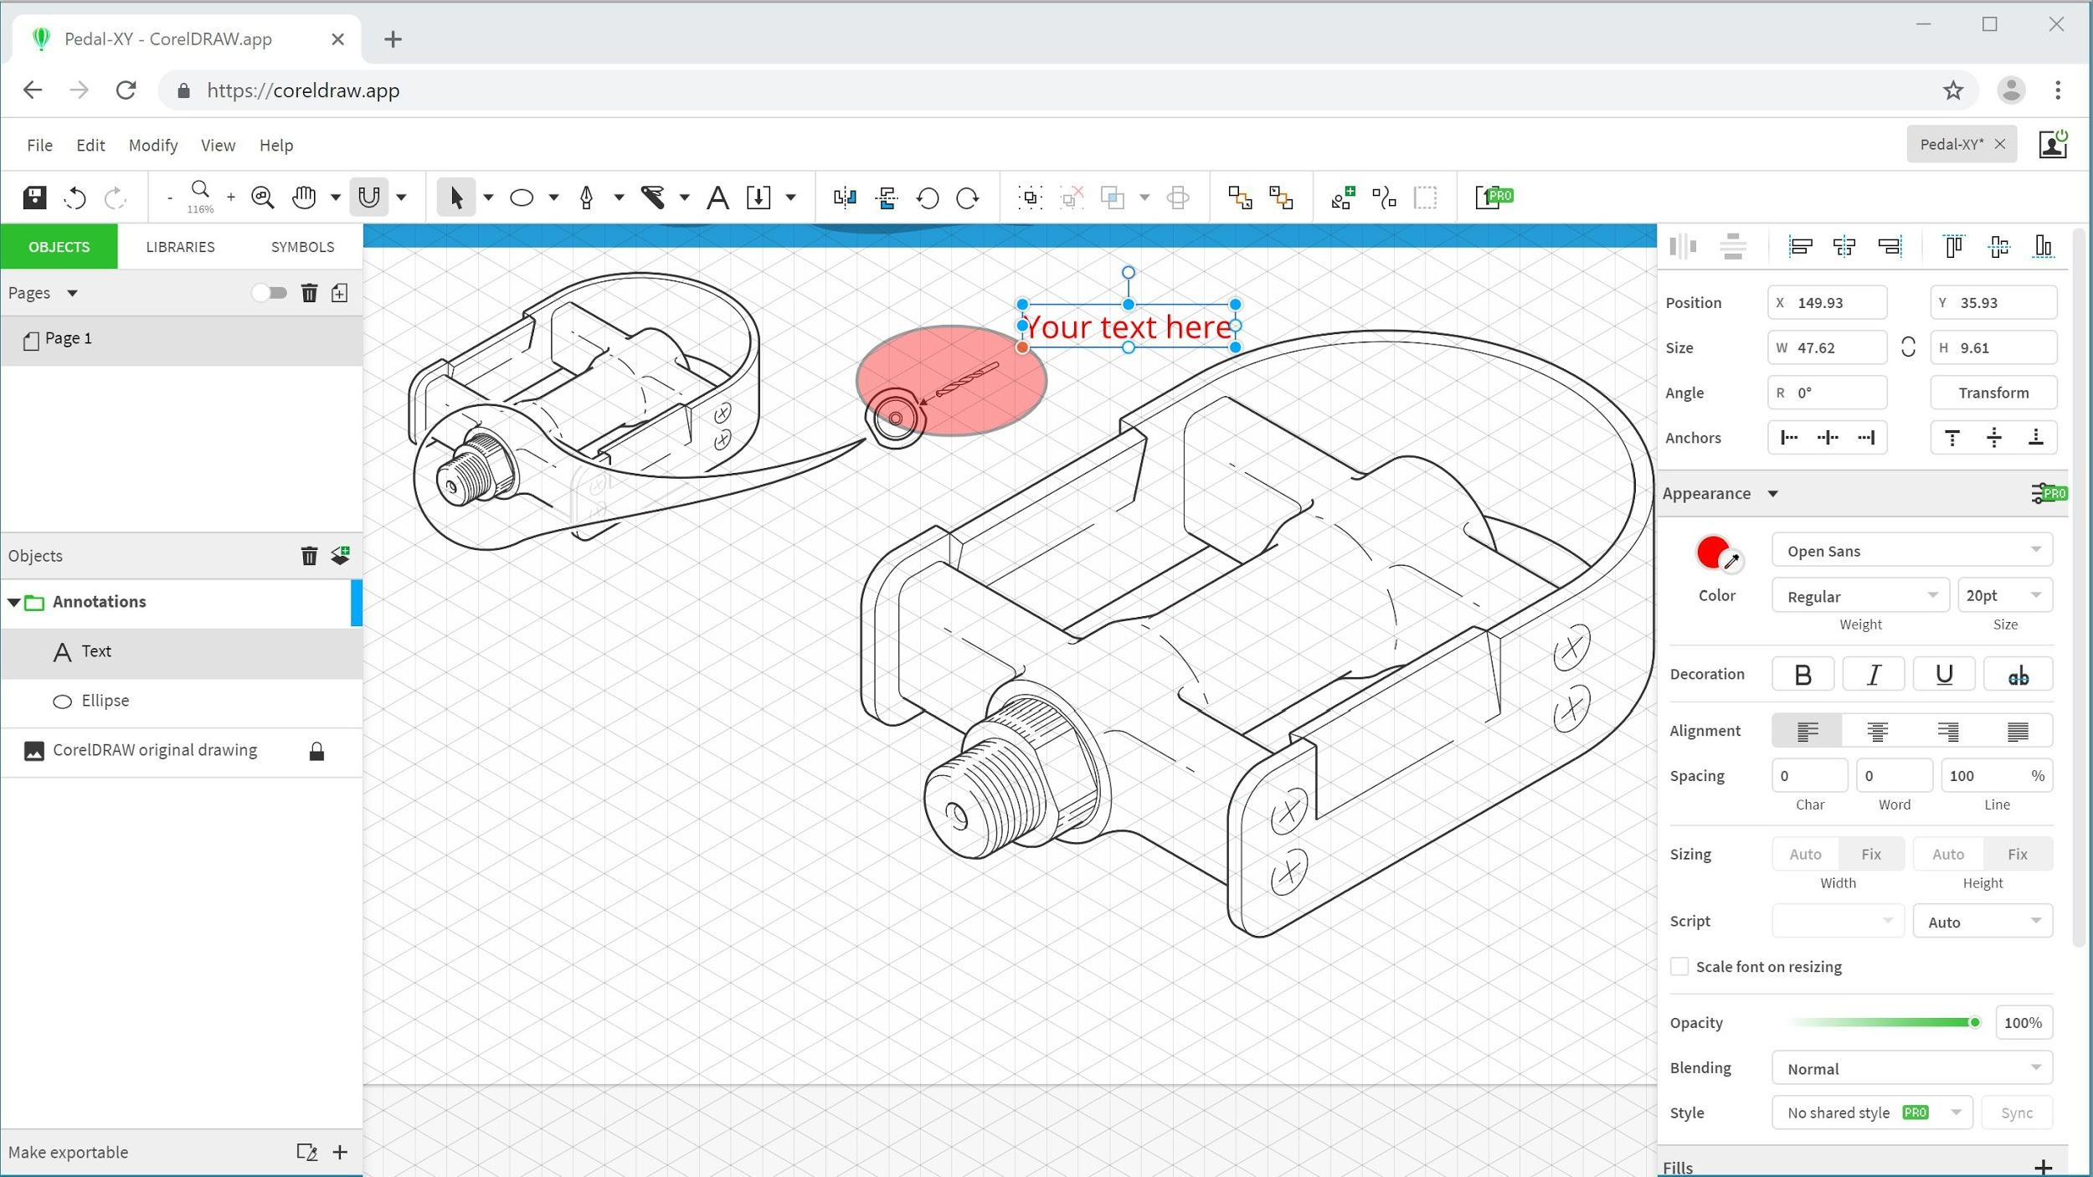
New CorelDRAW.app

Of course, if you’re looking to work faster (and who isn’t), the UI has been updated to allow for easier navigation and offers new shortcuts for commonly used tools. Boosted performance speeds startup time, document loading times, graphics rendering, text handling, and more.

We’re glad to introduce you to CorelDRAW Technical Suite 2019 and if its unique, extended technical illustration capabilities sound like they may be a valuable addition to your graphics toolkit, we invite you to learn more and download the free trial today! https://www.coreldraw.com/en/product/technical-suite/

Thanks for reading!

